Contributors to this project:

-Borzoo Farhang, DO, MS, MSHS

Assistant Professor of Anesthesiology

University of Vermont Medical Center

[borzoo.farhang@gmail.com](mailto:borzoo.farhang@gmail.com)

-Alec Gill

-Tom Caulton

1. Part List:
   1. NEMA 23 Stepper Motor: $39.99

<https://www.amazon.com/gp/product/B00PNEPW4C/ref=ppx_yo_dt_b_asin_title_o04_s00?ie=UTF8&psc=1>

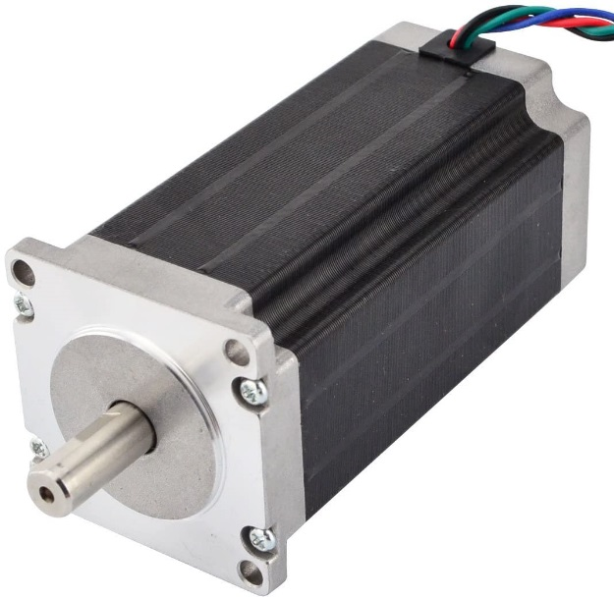

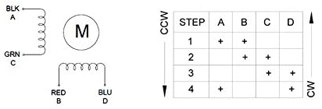b. 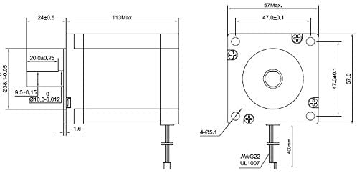

* 1. TB6600 Stepper Motor Driver: $10.75

<https://www.amazon.com/gp/product/B0839BBFVZ/ref=ppx_yo_dt_b_asin_title_o07_s00?ie=UTF8&psc=1>

Or: 9.99

<https://www.ebay.com/itm/Stepper-Motor-Driver-TB6600-4A-DC9-40V-for-Nema17-Nema23-Nema34-42-57-86mm/123554326786?ssPageName=STRK%3AMEBIDX%3AIT&_trksid=p2057872.m2749.l2648>

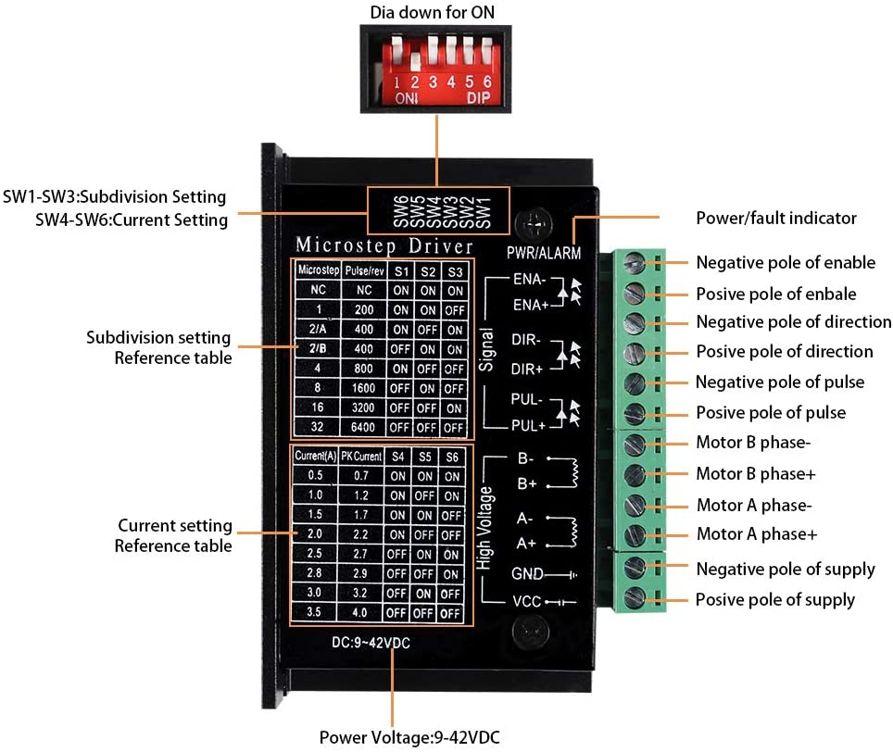

* 1. ARDUINO UNO R3: $19.89

<https://www.amazon.com/gp/product/B008GRTSV6/ref=ppx_yo_dt_b_asin_title_o04_s00?ie=UTF8&psc=1>

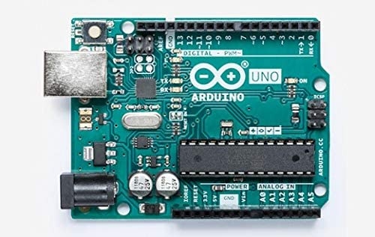

* 1. Power Supply for Arduino:
     1. $8.69

<https://www.amazon.com/gp/product/B01GD4ZQRS/ref=ppx_yo_dt_b_search_asin_title?ie=UTF8&psc=1>

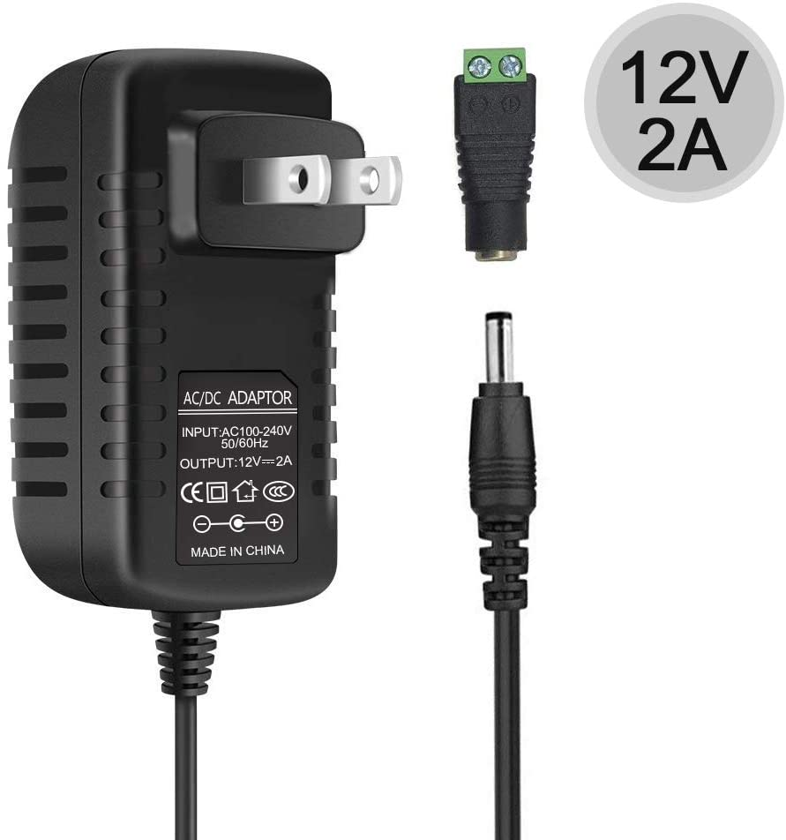

* + 1. Alternatively: Buck converter $5.95

LM2596s Buck Converter DC to DC Step-down Voltage Regulator Power Module 36V 24V 12V to 5V 2A Voltage Stabilizer with LED Display

<https://www.amazon.com/gp/product/B07CVBG8CT/ref=ppx_yo_dt_b_search_asin_title?ie=UTF8&psc=1>

* 1. Power Supply for the Motor: $24.99

<https://www.amazon.com/gp/product/B06XK2ZNKC/ref=ppx_yo_dt_b_asin_title_o05_s00?ie=UTF8&psc=1>

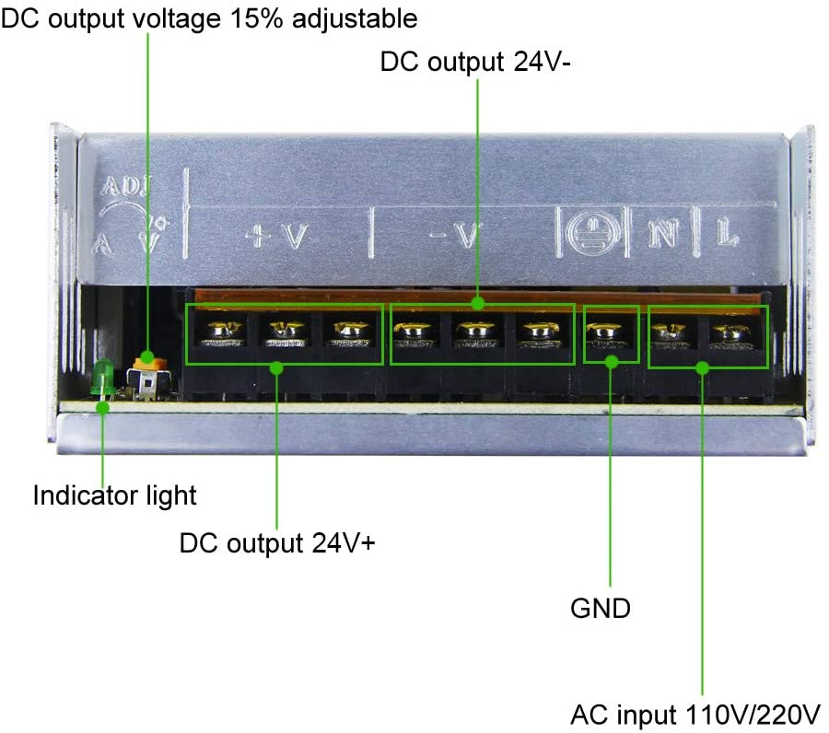

* 1. LED Indicator Red-Green $15.53

<https://www.digikey.com/product-detail/en/dialight/5571402203F/350-2756-ND/2430778>

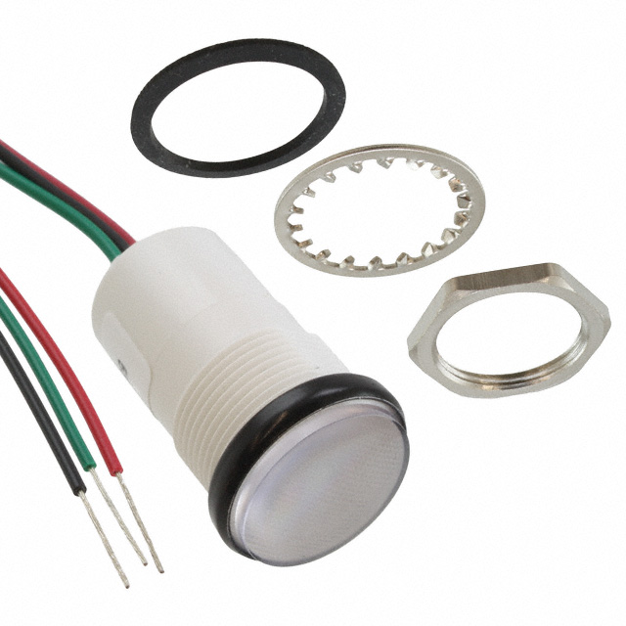

* 1. Limit Switches $0.79 (URBEST AC 250V 5A SPDT 1NO 1NC Momentary Hinge Roller Lever Micro Switches 3 Pins 10 Pcs)

<https://www.amazon.com/gp/product/B00MFRMFS6/ref=ppx_yo_dt_b_asin_title_o07_s00?ie=UTF8&psc=1>

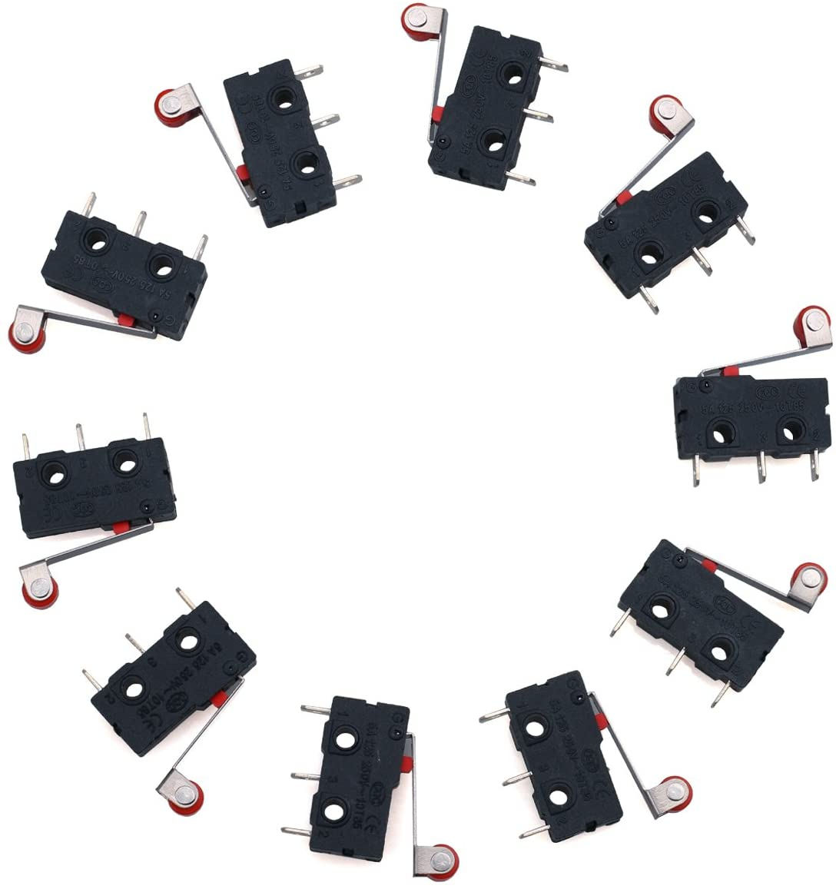

* 1. Arduino Sound Module $1.56 (Oiyagai 5pcs DC 3.3-5V Passive Low Level Trigger Buzzer Alarm Sound Module for Arduino)

<https://www.amazon.com/gp/product/B0777P6FN5/ref=ppx_yo_dt_b_asin_title_o06_s00?ie=UTF8&psc=1>

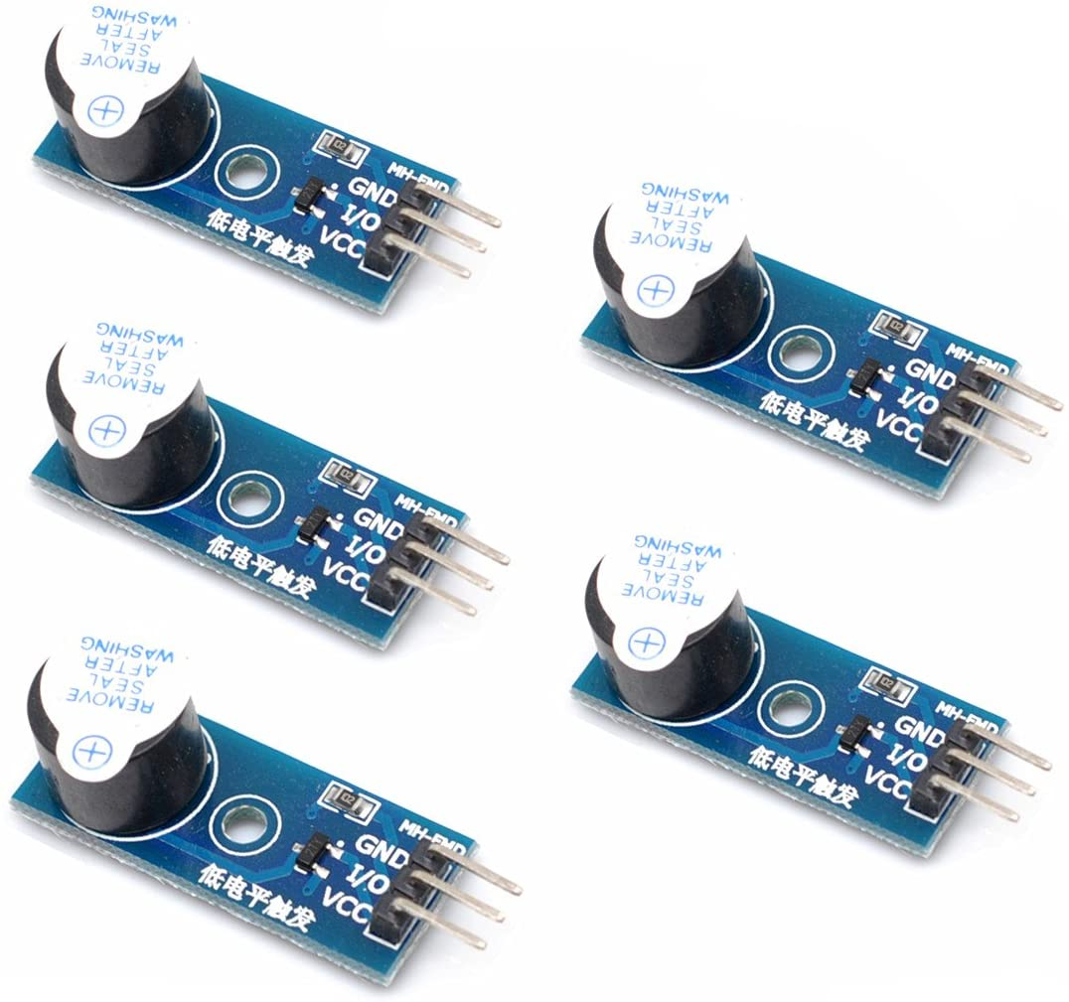

* 1. Power Switch (still deciding)
  2. Push Button $10.50

<https://www.digikey.com/product-detail/en/e-switch/PV0H240SS-341/EG5391-ND/5964418>

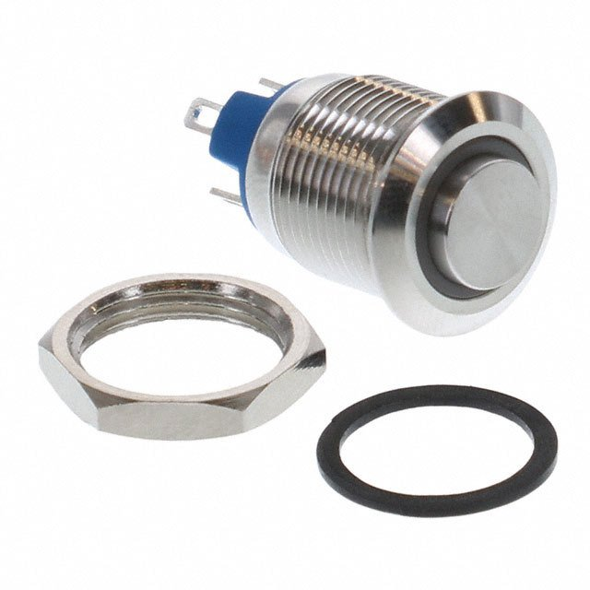

* 1. Optional Power Connector $8.66 Qualtek 761-18/003

<https://www.digikey.com/product-detail/en/qualtek/761-18-003/Q300-ND/417914>

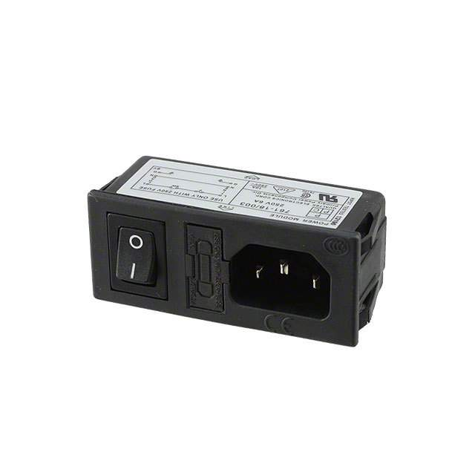

* 1. Potentiometer (Optional): $0.5

<https://www.ebay.com/itm/20pcs-10K-ohm-Linear-Taper-Rotary-Potentiometer-Panel-pot-B10K-15mm/392123626642?ssPageName=STRK%3AMEBIDX%3AIT&_trksid=p2057872.m2749.l2649>

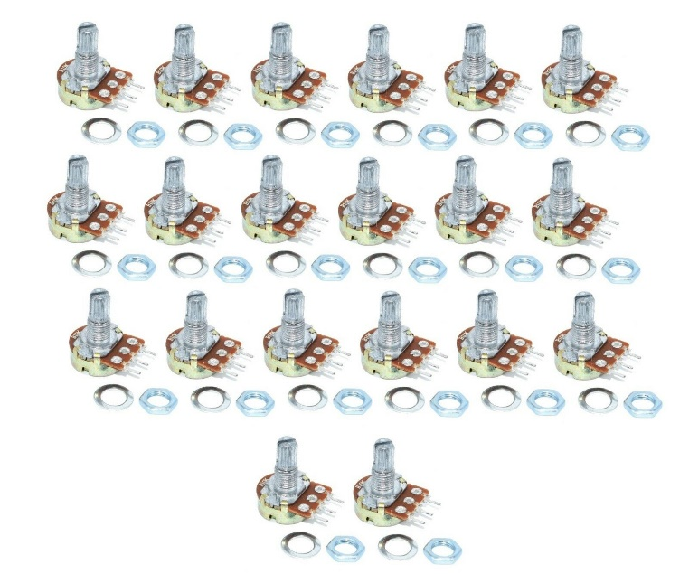

Optional Tools and Accessories:

1. Jumper Cables: $6.90

<https://www.amazon.com/gp/product/B01EV70C78/ref=ppx_yo_dt_b_search_asin_title?ie=UTF8&psc=1>

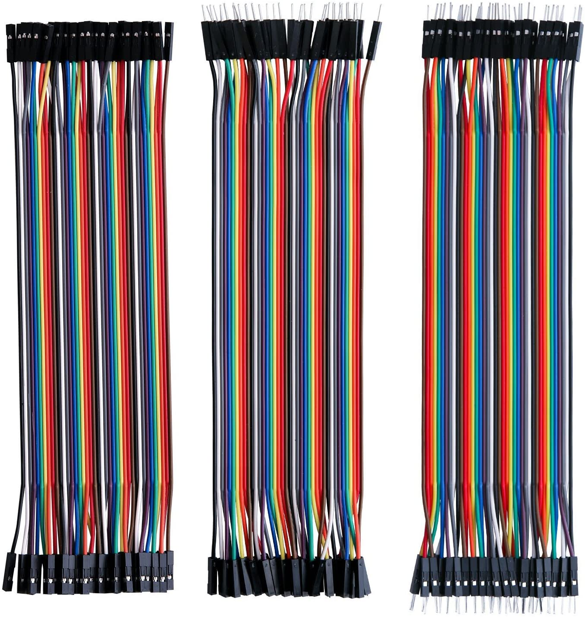

1. Screws: $24.99

<https://www.amazon.com/gp/product/B07H4MG7TC/ref=ppx_yo_dt_b_asin_title_o04_s00?ie=UTF8&psc=1>

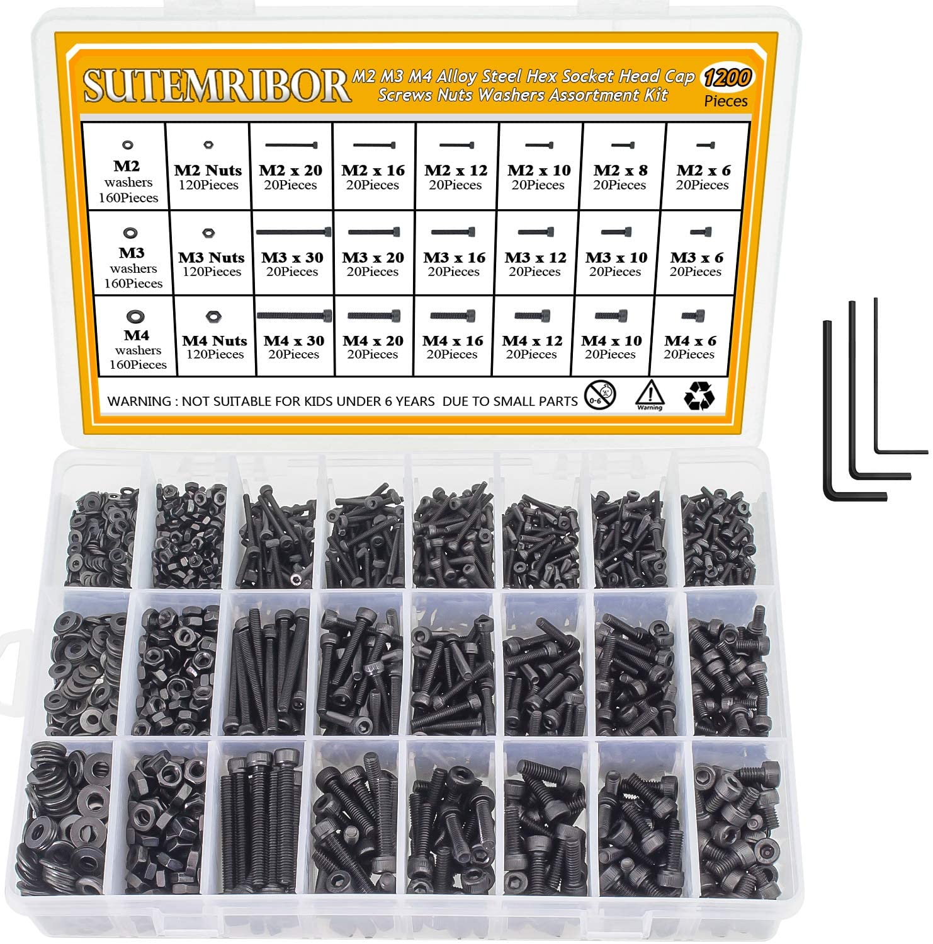

1. There are a few sets of wires to combine like the + of potentiometer 1 and 2. You can use any of the technics below:
   * 1. a crimping tool ($40.39) (<https://www.amazon.com/gp/product/B002AVVO7K/ref=ppx_yo_dt_b_search_asin_title?ie=UTF8&psc=1>) with Dupont connectors (27.99) (<https://www.amazon.com/gp/product/B078RRPRQZ/ref=ppx_yo_dt_b_search_asin_title?ie=UTF8&psc=1>)
     2. Solder cables together and use electrical tape around it
     3. Use a breadboard ($11.99) (<https://www.amazon.com/gp/product/B0727X6N9D/ref=ppx_yo_dt_b_search_asin_title?ie=UTF8&psc=1>)
     4. Use PCB board ($12.99) <https://www.amazon.com/gp/product/B079DN31SW/ref=ppx_yo_dt_b_search_asin_title?ie=UTF8&psc=1>
2. Connections:

|  |  |  |  |  |
| --- | --- | --- | --- | --- |
| From Device | From | To | | To Device |
| 15A Power Supply for Motor | L | L (Live) of Line to the wall | | 120V Outlet |
| N | N (Neutral) of Line to the wall | |
| Ground | Ground of Line to the wall | |
| V- | GND on Stepper Driver | | TB 6600 Stepper Driver |
| V+ | VCC on Stepper Driver | |
| V- (optional) | V- In on Buck Converter | | Buck Converter |
| V+ (optional) | V+ In on Buck Converter | |
| TB 6600 Stepper Driver | VCC | V+ | | 15A Power Supply for Motor |
| GND | V- | |
| A+ | Black Wire | | Stepper Motor |
| A- | Green Wire | |
| B+ | Red Wire | |
| B- | Blue Wire | |
| PUL+ | 9 | | Arduino |
| PUL- | GND (Combine PUL-, DIR- and ENA- all and connect to GND of Arduino) | |
| DIR+ | 8 | |
| DIR- | GND (Combine PUL-, DIR- and ENA- all and connect to GND of Arduino) | |
| ENA+ | 13 | |
| ENA- | GND (Combine PUL-, DIR- and ENA- all and connect to GND of Arduino) | |
| Stepper Motor | Black Wire | A+ | | TB 6600 Stepper Driver |
| Green Wire | A- | |
| Red Wire | B+ | |
| Blue Wire | B- | |
| Arduino | 8 | DIR+ | | TB 6600 Stepper Driver |
| 9 | PUL+ | |
| 13 | ENA+ | |
| A0 | Middle Pin Potentiometer 1 (Tidal Volume) | | Potentiometer 1 and 2 |
| A1 | Middle Pin Potentiometer 2 (Resp. Rate) | |
| 5V | + (Combine + of potentiometer 1 and 2 and connect to Vin) | |
| GND | - (Combine - of potentiometer 1 and 2 and connect to GND) | |
| GND | Combine PUL-, DIR- and ENA- all and connect to GND of Arduino | | TB 6600 Stepper Driver |
| Power Supply Connection (or Buck Converter below) | 12V Power Adaptor | | |
| Vin | V+ Out | Buck Converter (Or Power Supply above) | |
| GND | V- Out |
| 6 | + | Arduino Sound Module | |
| GND | - |
| 3 | NC | Top Limit Switch | |
|  | Common |
| 2 | NC | Resp. Verify Limit Switch | |
|  | Common |
| Potentiometer 1 and 2 | Middle Pin Potentiometer 1 | A0 | Arduino | |
| Middle Pin Potentiometer 2 | A1 |
| + (Combine + of potentiometer 1 and 2 and connect to Vin) | 5V |
| - (Combine - of potentiometer 1 and 2 and connect to GND) | GND |
| Arduino Sound Module | + | 6 | Arduino | |
| - | GND |
| Top Limit Switch | NC | 3 |
| Common | GND |
| Resp. Rate Verify Limit Switch | NC | 2 |
| Common | GND |
| LED Light | + | 5V |
| Green | TBD |
| Red | TBD |
| Reset Switch | + | TBD |
| - | GND |

1. Settings:
   1. TB 6600 Driver:

Set on the side controller of the driver 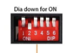

|  |  |
| --- | --- |
| 1 | Off (Up) |
| 2 | Off (Up) |
| 3 | Off (Up) |
| 4 | Off (Up) |
| 5 | Off (Up) |
| 6 | Off (Up) |

* 1. Arduino:

Code can be found at:

<https://github.com/zoorage/Ventilator-Prototype.git>

1. Video of Earlier Prototypes:

<https://www.youtube.com/watch?v=NUu_Q0IXxf4>

<https://www.youtube.com/watch?v=SI2yv-K0nfQ>